**Bug Report**

|  |  |
| --- | --- |
| Defect ID |  |
| Build Name | Register_ac |
| Build ID | B01 |
| Release Name | Release1 |
| Module Name | Register |
| URL | <https://demo.opencart.com> |
| Test Case Name | Opencart_register_ mandatory fields |
| Test Data | Not Applicable |
| Found By | Priyanka |
| Test Environment | OS- Windows 10  Browser- Chrome |
| Status | New |
| Severity | Minor |
| Priority | Low |
| Assigned to | Dev lead |

**Description**

All the mandatory fields marked with red * symbol

**Steps to reproduce**

1. Click on 'My Account' Drop menu  
2. Click on 'Register' option   
3. Check the Fields - First Name, Last Name, E-Mail, Telephone, Password, Password Confirm and Privacy Policy

**Expected result**

All the specified Fields in the Test Steps should be marked with red color * symbol

**Actual result**

Privacy policy checkbox field is mandatory but not marked with red * symbol

**Screen Shot**

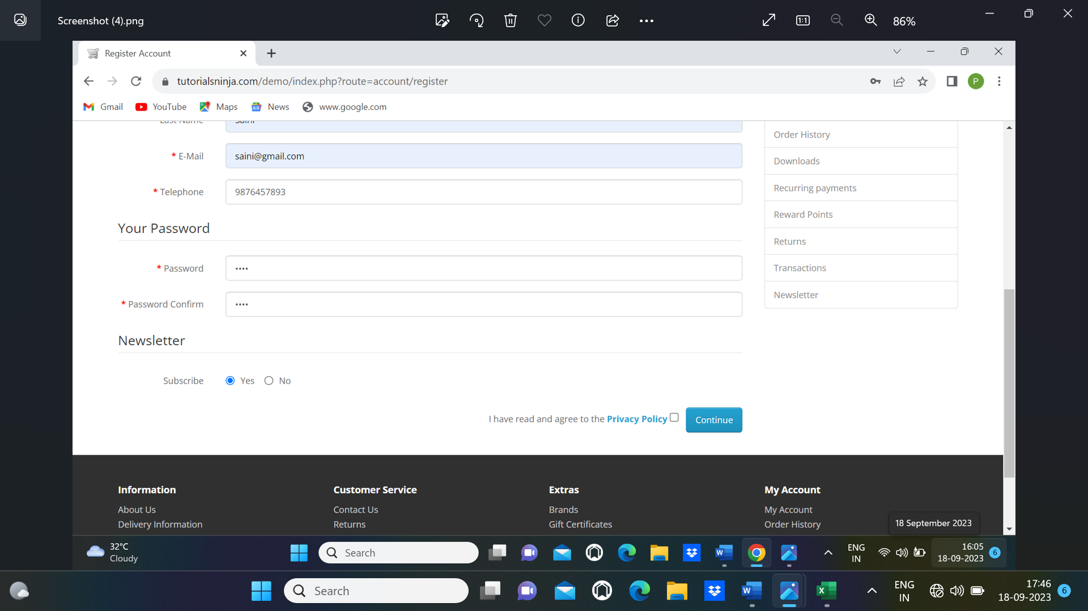

|  |  |  |
| --- | --- | --- |
| Submit | Clear | Cancel |